Guzon, Kean Louiz

DSA Lab

1. Draw the adjacency list and matrix representation of the weighted graph

|  |  |  |  |  |  |  |  |  |
| --- | --- | --- | --- | --- | --- | --- | --- | --- |
|  | **H** | **I** | **J** | **E** | **K** | **F** | **M** | **P** |
| **H** | 0 | 1 | 1 | 0 | 1 | 0 | 0 | 0 |
| **I** | 1 | 0 | 0 | 1 | 0 | 1 | 0 | 0 |
| **J** | 1 | 0 | 0 | 1 | 0 | 1 | 0 | 0 |
| **E** | 0 | 1 | 1 | 0 | 1 | 0 | 1 | 0 |
| **K** | 1 | 0 | 0 | 1 | 0 | 1 | 0 | 0 |
| **F** | 0 | 1 | 1 | 0 | 1 | 0 | 0 | 1 |
| **M** | 0 | 0 | 0 | 1 | 0 | 0 | 0 | 0 |
| **P** | 0 | 0 | 0 | 0 | 0 | 1 | 0 | 0 |

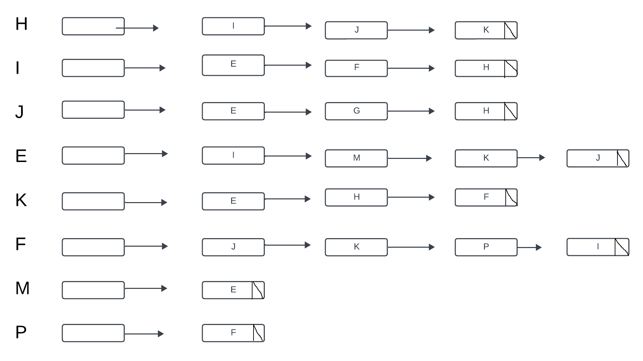

1. Redraw the graph using BFS algorithm

